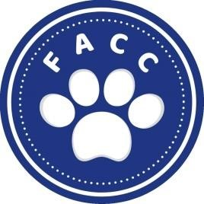
Montgomery County Friends of Animal Care and Control
Date:_____________________
General Membership Application
Name: ______________________________________________________________________________
Address;______________________________________________________________________________
City: ___________________________State:_________ Zip Code_________________________________
Phone Number:________________________________________________________________________
Email Address:_________________________________________________________________________
This application is for general membership, which means you are encouraged to:
Attend regular meetings of the Montgomery County Friends of Animal Care and Control (MCFACC)
Provide Input to the Board of Directors to improve support of the MCFACC mission and vision
Assist with MCFACC events such as outreach, fundraising and communications
****This is a non-voting member*****
Which Committee(s) would you like to serve on:
______Communications- Social Media, Website Design, Flyers and Brochures
______Financial
______Fundraising
______Outreach

What skills do you have that can help the MCFACC:
_____________________________________________________________________________________
_____________________________________________________________________________________
_____________________________________________________________________________________
_____________________________________________________________________________________
_____________________________________________________________________________________
Please rename document, then email completed form to: mcfaccboard@gmail.com

